RESOLUTION NO.__________

RE: CERTIFICATE OF APPROPRIATENESS UNDER THE
PROVISIONS OF THE ACT OF THE PENNSYLVANIA
LEGISLATURE 1961, JUNE 13, P.L. 282 (53
SECTION 8004) AND BETHLEHEM ORDINANCE NO.
3952 AS AMENDED.

The applicant proposes to demolish existing buildings (house and garage) and construct an apartment building at 143 W. Broad St.

NOW, THEREFORE, BE IT RESOLVED by the Council of the City of Bethlehem that a Certificate of Appropriateness is hereby DENIED for the proposal.

Sponsored by: (s)

(s)

ADOPTED BY COUNCIL THIS DAY OF

(s)
President of Council

ATTEST:

(s)
City Clerk

HISTORICAL & ARCHITECTURAL REVIEW BOARD

The applicant proposes to demolish existing buildings (house and garage) and construct an apartment building at 143 W. Broad St.

APPLICATION #5:

Skyline West, LLC
2005 City Line Road
Bethlehem, PA 18017

OWNER:

__________________________________________________________________________

The Board upon motion by Beth Starbuck and seconded by Marsha Fritz DENIED the proposal that City Council issue a Certificate of Appropriateness for the following:

- The denial was based on the “contributing” status of the existing building as
described in the PA Historical & Museum Commission’s Historic Resource form,
prepared by Spillman Farmer Architects dated 4-7-86.

2. The motion to deny the application was carried by a 4 to 3 vote.

__________________________________________________________________________

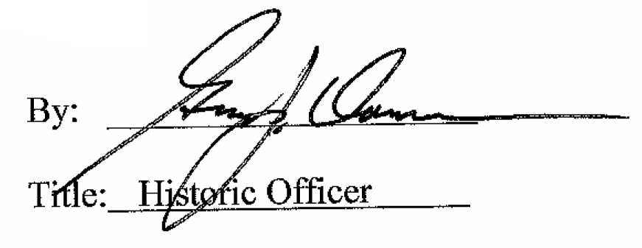

Date of Meeting: June 6, 2018

